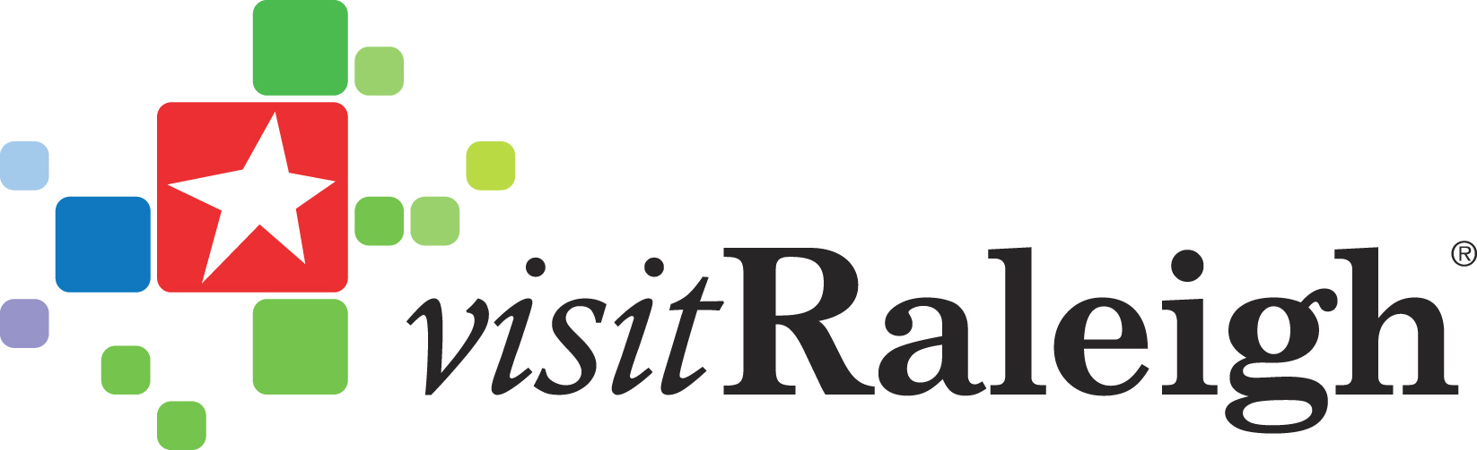 Contact: Ryan Smith
(919) 645-2676
rsmith@visitraleigh.com

CELEBRATE CULTURAL DIVERSITY IN GREATER RALEIGH THIS FALL
More than 10 Festivals Take Place Throughout North Carolina’s Capital City

Raleigh, NC – From steel drums to sombreros and baklava to bagpipes, the Raleigh area celebrates the world’s cultures with more than 10 community-wide festivals this fall. Consistently ranked as a top place to live, work and play by numerous national publications, the area lives up to that moniker by providing a sense of community and acceptance for a melting pot of cultures, religions and lifestyles. Discover many of the cultures which make this area a celebratory and dynamic place to be.
Festival season kicks off early this fall in downtown Raleigh’s City Plaza with two festivals – Jamaica Pride Picnic, August 9, for anyone and everyone that loves reggae music, steel drums, and celebrating all things Jamaican, and CaribMask Caribbean Festival, Aug. 23, featuring dancing, masqueraders, Caribbean arts and crafts, and lots of fun Carolina Caribbean vibes to turn City Plaza into a tropical paradise. Make sure you don’t miss out on Cedars in the Pines: The Lebanese in North Carolina at the NC Museum of history for 130 years of commemorative Lebanese history that last until Aug. 31.
The tropical music may have stopped, but don’t let the celebrating come to an end just yet. The 5th Annual African American Cultural Festival of Raleigh and Wake County, Aug. 30 – 31, held in downtown Raleigh’s City Plaza, takes celebrating to a whole new level by filling the streets with dozens of artists, musicians and food vendors to teach, share, and celebrate African American culture with the Greater Raleigh community. With more than 50 cultural heritage sites, North Carolina’s capital city area is rich in African-American heritage from the African American Cultural Center to Shaw University and Saint Augustine’s University, two of the oldest historically black universities in the South.
End your week by going Greek at The Greek Festival, Sept. 12-14, at the NC State Fairgrounds for a weekend filled with live Greek music, dancing, crafts, cultural traditions and of course, lots of handmade, authentic Greek food. If you don’t want to limit yourself to just one country; discover the world at The 29th International Festival of Raleigh, Sept. 19 – 21, at the Raleigh Convention Center for three days filled with music, food, and culture from around the globe. Watch authentic ethnic dances from over 30 different cultures, shop the World Bazaars for international crafts, or taste your way around the globe; whichever you choose, it’s a worldwide wonder that you won’t want to miss.
If you’re looking for one day filled with good food, great music, and is fun for the entire family, La Fiesta del Pueblo, Sept. 21, encompasses all those aspects while celebrating the Latino culture and community. Between folk music and art, dance performances, educational booths and children’s activities, make sure to save room for some churros, tortillas, tacos and other tasty Latino cuisines.
The Raleigh area has an active Gay, Lesbian, Bisexual and Transgender (GLBT) population and these communities come together during NC PrideFest 2014, Sept. 27, in venues throughout Durham and Raleigh. In downtown Raleigh, festival-goers are encouraged to “Embrace the Night” with local performers and events at area bars and restaurants.
Experience for yourself why the Irish music extravaganza that started out as an Irish family picnic is now one of the most spirited and lively events in the Raleigh area. The Raleigh Irish Music Festival, Oct. 4, is fun for all, whether you’re Irish or not. Admission is free and is a great price to pay for a day filled with Irish singers, dancers, food, beer and of course, bagpipes.
It may be a celebration of foreign culture to some, but the NC State Fair, Oct. 16-26, is a celebration of all things North Carolina. From food products native to North Carolina to livestock showcases, corn-on-a-stick and deep-fried anything; the largest event in the state gives visitors a glimpse into the simple pleasures that make our state a unique and dynamic place to visit.
Celebrate American Indian Heritage Month by attending the American Indian Heritage Celebration, Nov. 22, at the N.C. Museum of History in downtown Raleigh. Meet members of North Carolina’s eight state-recognized tribes, hear and feel the drumbeats, watch dancers in glorious regalia, and take in the sights and sounds of this exciting festival with the largest American Indian population east of the Mississippi River.
If you can’t fit any of these fun festivals into your schedule, you can still taste the many cultures of the world that Greater Raleigh has to offer all year round. Get a little taste of the islands at Caribbean Café or Jamaica Café in North Raleigh or try your hand at some authentic Ethiopian cuisine at Abyssinia Ethiopian Restaurant or Ashlee Ethiopian Cuisine. Check out other wonders of the world like Bida Manda with its traditional Laotian cuisine or BuKu and its global street food that is bound to take your taste buds all over the world.
For more information on any of these cultural festivals and other area attractions, or to book special packages and rates during the fall, go to www.visitRaleigh.com.
###
The Greater Raleigh Convention and Visitors Bureau, as the official destination marketing organization of Raleigh and Wake County, accelerates sustainable economic growth and development by increasing visitor and convention business. Through its website, www.visitRaleigh.com and other tools, the GRCVB assists local visitors in a variety of ways.

